

Directed by:
- Hassan Said Hassan Hussien (Team Leader) 200234
- Ahmed Mohammed Hamed Elnoamany 190065
- Mohammed Nabil Mohammed 200626
- Mohammed Mostafa Mostafa Hamed 200622
- Abdelrahman Kadry Ramadan Ali 200393
- Mostafa Baiomy Abdelsattar Elshaplangy 200690
- Abdallah Magdy Mohammed Ibrahim 190551
- Radwa Ali Ibrahim Ahmed Elhaj 200267
- Habiba Abdullatif Kotp Gaballah 200226
- Eman Mohammed Meligy Emam 200188

E-Commerce APP
  - Flutter - Web App (React-js)

E-Commerce APP
  - Flutter

CONTENTS
1 INTRODUCTION................................................................................................................................ 5
2 BACKGROUND AND PURPOSE........................................................................................................6
2.1 Project Background.......................................................................................................................... 6
2.2 Project Objectives ........................................................................................................................... 6
2.3 Comparative Analysis ..................................................................................................................... 7
3 ANDROID APPLICATION REQUIREMENTS AND DEVELOPMENT ………………………………… 8
3.1 Ecommerce Application Development ............................................................................................ 8
3.2 Android App development............................................................................................................... 9
3.3 Functional Requirements ................................................................................................................ 9
3.4 Non-Functional Requirements ....................................................................................................... 10
3.5 GUI (Graphical User Interface)........................................................................................................10
4 TECHNOLOGY.................................................................................................................................. 12
4.1 Flutter.............................................................................................................................................. 12
4.2 Android............................................................................................................................................ 13
4.3 Dart Language ................................................................................................................................ 13
4.4 Google Firebase.............................................................................................................................. 14
4.5 Android Studio................................................................................................................................. 15
5 TECHNICAL IMPLEMENTATION...................................................................................................... 16
5.1 Planning .......................................................................................................................................... 16
5.2 MVVM (Model-View-View Model).................................................................................................... 16
5.3 Configuration and Customization .................................................................................................... 17
5.3.1 Flutter Firebase working ............................................................................................................... 18
5.3.2 Firebase Configuration for Android and IOS:................................................................................ 19
6 CODE EXPLANATION ....................................................................................................................... 21
6.1 Assistance from the open sources and friend ................................................................................. 21
6.2 Whole Application background Function calling............................................................................... 21
6.3 Home Screen .................................................................................................................................. 23
6.4 Login Registration Screen................................................................................................................ 24
6.5 Add to Card Screen.......................................................................................................................... 25
7 Discussion and Further Development................................................................................................. 26
REFERENCES ...................................................................................................................................... 27

ABBREVIATIONS AND TERMS

TAMK
- Tampere University of Applied Sciences
OS
- Operating system
iOS
- iPhone operating system
API
- Application Programming Interface
SDK
- Software development kit
Firebase
- Database management service from Google. Here you
can store all your online data.
C and C++
- Programming languages used for software development
JavaScript
- A web-based programming language
Json
- JavaScript Object Notation
Array
- An object that contains multiple values.
Array index
- the order of a data in an array
Init function
- Init function runs for the initialization of the software
Stateful widget
- A stateful widget describes the part of user interface
Stateless widget
- the state which cannot be changed while the program is
running
Query
- A method for requesting a data from database

1 INTRODUCTION
In this thesis, the Flutter technology is utilized to develop an e-commerce mobile
application. E-commerce, or electronic commerce, is a technique of purchasing
goods and services through the internet that is growing in popularity and
effectiveness for online businesses. Ecommerce offers a number of benefits, the
most significant of which is that it is inexpensive and convenient.
As a consequence, we may describe e-commerce as the process of buying and
selling goods and services through the internet, whether inside a country or
across the globe. These companies have their own mobile apps or websites
where customers may explore a range of products and services.
They have a choice of payment alternatives if they purchase anything and need
to pay for it, including (credit card, debit card, PayPal). utilizing a website or a
smartphone app the order is shipped to the customer's address after
confirmation. If required, customers can follow the status of their orders. All of
these things happen on the internet. (A Review of Narrative Literature of e
commerce, 2017). This application's main purpose and goal is to empower and
assist a person in accessing e-commerce platforms so that they may do their own
online shopping

2 BACKGROUND AND PURPOSE
2.1 Project Background
Electronic commerce, generally known as online business and trade, alludes to
the acquiring and selling of products and services well over internet. In the 1960s,
the term "ecommerce" was coined. With the growing usage of mobile devices,
social media has emerged as an effective reinforcement of the web page's
strength. (salesforce)
Ecommerce (electronic commerce) is the term used to describe all online activity
along with the purchase and sale of goods and services. To put it differently,
ecommerce is the process of doing transactions over the internet. Ecommerce
has existed since 1994, when Phil Branden Berger bought the first product online,
Sting's "Ten Summoner's Tales." By 2021, an estimated 27.2 percent of the
world's population will be shopping online. (Oberlo, no date)
To deliver information to individuals, several innovative strategies and
innovations in e-commerce applications have been established. Globally, online
shopping has experienced substantial growth. Online shopping is used by 21.8
percent of the world's population. You're missing out on a huge group of potential
purchasers if you're not selling online. 73% of customers browse across several
channels, including Google, social media, and email. (salesforce)
2.2 Project Objectives
In recent years, online purchasing has become increasingly popular. People all
around the world prefer to buy things online rather than in stores, which is why
Amazon and other similar online retailers are not only successful but also
increasing interest in online commerce. (Darrell, 2011)
In today's world, though, innovation is assisting us in breaking down some of
these barriers by using computer frameworks to aid us with various forms of
labour. As we all know, the world of online purchasing is quickly developing. As
a result, e-commerce apps have already developed various new tactics and
technologies for giving information to individuals. These ideas and technologies,
however, provide a number of challenges and concerns for people. (sgrlaw)
2.3 Comparative Analysis

Existing Solutions | Proposed Solution
Assists in the improvement of our  standard, carefully crafted products  for distribution within the showcase. | More attractive user interface.
The framework allows a buyer to  quickly explore or search for an item. | Faster Server-to-client-side response.
It provides an easy way to purchase  items directly from sellers without  the use of a third-party interface | Tried to make the rural individuals fill out  the description form which will provide  more about their products.
Tried providing a better and user
friendly environment than the existing
one.

3 ANDROID APPLICATION REQUIREMENTS AND DEVELOPMENT
3.1 Ecommerce Application Development
The history of e-commerce dates back more than 50 years, when early inventions
such as EDI (Electronic Data Interchange) and teleshopping were shown in the
1970s, paving the way for today's e-commerce companies. The history of e
commerce is inextricably linked to the history of the internet. When the internet
was invented in the 1990s, online shopping became possible. Since then,
Amazon has become one of the most popular e-commerce sites in the United
States, with hundreds of e-commerce enterprises springing up as a result.
(Everydayonlinemarketing, no date)
Michael Aldrich demonstrated e-shopping by connecting a phone connection to
an adjustable TV and a transaction-processing computer. (Aldricharchive, no
date)
While desktop spending has remained stable throughout the year, the worldwide
market for online business transactions has grown at an annual rate of 33.7
percent since 2016. This happens as a result of customers' continuous
preparation with each screen tap. The creation of mobile applications for e
commerce enterprises appears to be a long-term trend, according to simple
reasoning. Nothing suggests that the worldwide public will soon reject
smartphones. Diverse internet shopping, on the other hand, is predicted to reach
$3.5 trillion by 2021. (Shopify, no date)
The e-Commerce business is experiencing the most notable growth of adaptable
arrangements being prompted by the need to meet client needs in the context of
rising online sales. Customers want the ability to purchase items and services at
any time and from any location, without having to travel. Customers choose
various e-commerce applications or websites to purchase things because they
advance faster, give more comfort, and are more flexible.
For As a mobile application developer, it's important to remember the distinctions
between mobile development and more traditional software development.
Consider how varied the settings for utilizing mobile apps vs desktop computers
can be, for example, recognizing the constraints and complexities of a touch
based user interface, and considering the unique security vulnerabilities that
mobile technologies provide. A mobile developer should also be mindful of the
importance of user experience and the fact that most users are acclimated to a
certain operating system's design guidelines. (creativebloq, no date)
3.2 Android App development
Android app development is the process of creating mobile apps for devices using
the Android operating system. Languages like C, object-oriented languages (like
Java), and the SDK (Android Software Development Kit) are used to create
Android applications. Android was initially introduced in 2009, and it is based on
the Java programming language. In today's world, Android dominates the whole
portable app sector, with the majority of the market share and a global clientele.
3.3 Functional Requirements
The functional requirements for this application that are necessary to complete
this project are as follows:
• Application must start when client clicks on app icon
• Application must show the home page of the application first
• Application must provide the selected category’s content list for the client
• Client must be able to view the products
• Client must be able to view the products image
• Application must provide the selected product’s description for the client
• Client must be able to add the product to the cart
• Application should add the product to the customer’s shopping cart.
• Application must provide the customer’s information form for the client.
• Client must send the provided credentials to the application.
3.4 Non-Functional Requirements
The non-functional requirements for this application that are necessary to
complete this project are as follows:
• Application should have an interface to display products to the customer.
• Application should have an interface to display list of categories
• Application should be able to display list of categories, so customers easily
click on them
• Application should be able to display a product’s description
• Application should have an interface for the customer to add a product to the
shopping cart

3.5 GUI (Graphical User Interface)

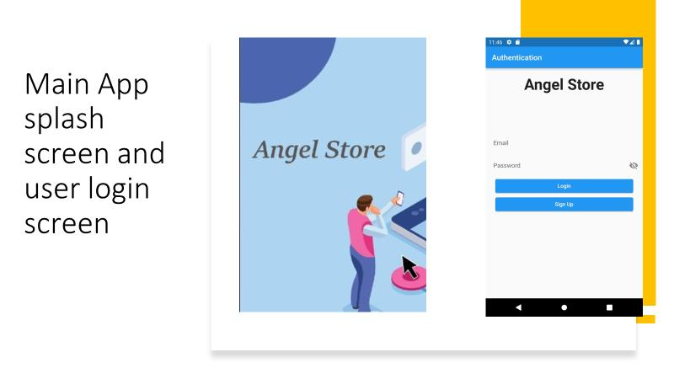
Figure 1: Customer login and splash screen

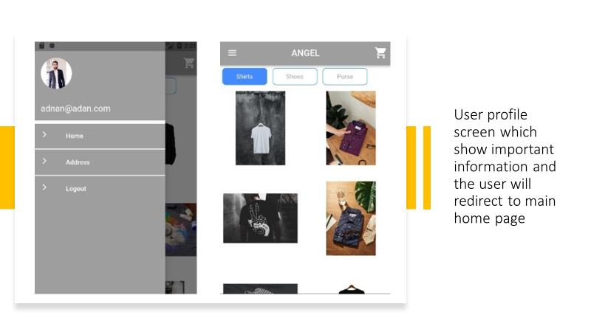
Figure 2: Profile and main screen

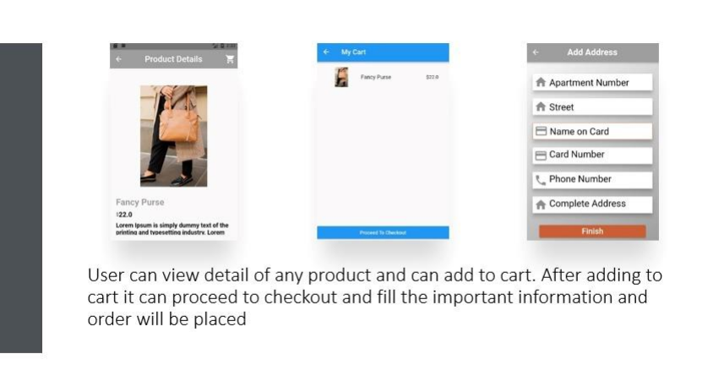
Figure 3: Order processing

4 TECHNOLOGY
4.1 Flutter
This application is built on Flutter technology. Flutter offers several advantages
because it is a Google product. The following is a quick overview of flutter.
The app development process is revolutionized by Flutter. You can design, test,
and publish stunning mobile, web, desktop, and embedded apps by writing one
time code. Google built Flutter as an open-source project. It's used to make hybrid
apps for Android, iOS, Linux, macOS, Windows, Google Fuchsia, and the web
from a single codebase. (Flutter, no date)
You can develop and iterate quickly using Hot Reload. You'll observe changes
very immediately after updating the code, with no loss of state. Maintain every
pixel to create unique, responsive designs that look and feel great on every
device.
Every component in flutter is referred to as a widget. It is entirely widget based.
Stateless or stateful widgets are available. There are several states in a stateful
widget, not just one. They have the ability to modify their state in response to user
interest. A Stateless widget, on the other hand, is a static widget that is utilized
for static data or functionality. It is devoid of any state. We need to utilize it in
some circumstances because we work with static data. (AppDividend, no date)
Flutter is an open-source project, anybody may use and contribute to it at any
level. It's better to use it and offer your passion for Google technology by
becoming a Google contributor. Flutter has a massive user base since it is a
Google product, and Google is the most widely used search engine on the planet.
Flutter outperforms other hybrid solutions in terms of cost. It's one of the many
advantages of flutter. Flutter developers may encrypt app data with both
asymmetric and symmetric keys using the iOS SecKey API and the Common
Crypto library. Flutter code is written in Dart, which has many cryptos and
encrypts libraries that employ various cryptographic hashing and encryption
techniques.
4.2 Android
Android is a multitasking mobile operating system that runs on smartphones,
tablets, readers, televisions, and even domestic robots. Google purchased and
marketed this operating system, which was developed by 'Android Inc' and based
on Linux. Android's introduction as an operating system (OS) in 2008 was a
spark, and it quickly became popular among smart gadgets. Modern
smartphones and tablets might be considered stash minicomputers thanks to this
operating system.
By 2020, the Android platform will have about 35 billion users worldwide, making
it the most popular mobile operating system on the planet. A large number of
smart gadgets run on this operating system (like phones, tablets, and
smartwatches). Every company organization or brand in the world nowadays
need an e-commerce Android app in order to grow their business, money, and
popularity. (Android, no date)
Android is a very adaptive and engaging system, and a basic acquaintance takes
less than an hour. Because there are so many essential programs accessible,
any customer may easily configure OS settings. You can modify everything past
recognition: if you don't like the look, symbols, or ringtone, simply go to the
Google Play Store, download a significant program, and quickly customize
everything to your desire
4.3 Dart Language
Dart is a client-oriented programming language that enables rapid app
development across all platforms. Its primary goal is to create one of the most
productive languages on a variety of platforms. Both the server and the user will
benefit from it. The Dart SDK includes the Dart VM compiler as well as the dart2js
tool, which generates the JavaScript version of a Dart Script so that it may be
executed on sites that don't support Dart. It is a very similar object-oriented
programming language to C++. Dart is a popular programming language for
creating single-page websites and online apps. (Dart, no date).
Dart is designed to provide logic and, as a result, a beautiful user interface. For
mobile, desktop, and backend apps, compile specialized machine code.
Alternatively, for web use, compile to JavaScript.
Benefits
The first advantage is that it is a very easy language to pick up. If any of us are
familiar with C or C++, we can quickly learn this language because the grammar
is comparable. The vast community, which provides extensive documentation, is
the second item to note. And because it's a Google product, they make it as
simple as possible. The third advantage is its excellent performance. Dart-based
programs are faster to execute than JavaScript-based programs. (Code Carbon,
2020)
Drawback
Of course, we must consider the drawbacks in addition to the rewards. The first
disadvantage is that it has limited resources, making it harder to find solutions to
problems. This is due to a lack of larger and more cohesive development
communities to assist you.
Dart is currently in development. That's fantastic, and there's nothing "wrong" with
Dart, but if you start writing in Dart today, the API may change, or things may not
be fully or accurately documented, and the quantity of knowledge accessible on
the web may be less than, example, the amount of information available on
jQuery. (Code Carbon, 2020)
4.4 Google Firebase
Firebase is a Google program that allows developers to create apps for a variety
of platforms, including iOS, Android, and web-based apps. Firebase is a quick
tool for developing things that would take a long time in a traditional database
system, such as bespoke APIs. Firebase has built-in APIs that allow us to
construct applications quickly. One of the nicest features of Firebase is that it
gives us tools for tracking business reports and experimenting with different
goods.
The Firebase database is a real-time database that allows clients to immediately
access data. Even if you are not connected to the internet, you can still use your
program with all of your prior data sets. Firebase allows users to use data in a
secure and secured manner.
The Firebase database is a NOSQL database, similar to the MYSQL database
used in PHP applications. The real-time database API was created exclusively
for rapid operations and capabilities. (Firebase, no date).
4.5 Android Studio
It's a Google-created integrated development environment (IDE). The goal of
Android is to speed up progress and make it easier for users to create high-quality
apps for Android devices. Commonly used operating frameworks, such as Mac
and Windows, allow variations of this IDE. It also provides a development kit and
plugins for developers. cross-platform application support (IDE)

5 TECHNICAL IMPLEMENTATION
5.1 Planning
The initial stage in our project's technological execution is to plan what we want
to build that will benefit our society. We've attempted to question everything that
may be touched by the program up to this point:
• Will the development take place in stages or all at once?
• How much time will it take?
• Will there be new security challenges?
Finally, we want to create an ecommerce software that allows users to purchase
items without having to go to an actual store or shop. This is an excellent concept
for easing the difficulties faced by many folks who are unable to go to the market
to purchase goods. An entire store is there at their fingertips; all they have to do
is scroll and choose the things that best suit their needs.
5.2 MVVM (Model-View-View Model)
The app's current design is built on the MVVM paradigm, which employs a well
known provider pattern. Views in this design closely monitor the view Model and
react to any changes that are detected. We have a home-view that is watching
Data View Model, and the Data View Model has a reference to the model in our
example.
In the Data View Model, we have a method for filling categories that is responsible
for adding categories to the list of categories and informing the listener, much like
populating categories. The Home-view has a Horizontal List View widget that
monitors the category list and updates the content of the list View whenever the
list is modified.
The same goes for categorizing items and filling them. The Data View Model has
three methods: getShoes(), getPurse(), and getShirts(). When we choose a
category, it queries the items in that category and alerts the Grid view widget,
which oversees displaying products. The Selected Product reference variable in
the DataViewModel is responsible for displaying product details on the product
details page.
When we pick a product from the Home Page, we update the reference variable
for that product, which is visible in the product details page, and we alter the
content of the detail page appropriately. In DataViewModel, we additionally keep
track of the listOfCartProducts. We update the listOfCartProducts in
DataViewModel when we add a product from the details page to the cart. This
variable is tracked in the cart Screen and updates the listView widget when the
list changes.
Furthermore, we manage users using Firebase authentication. Orders may only
be placed by authenticated users. We built a project for Angel for firebase
configuration, and under Project, we developed an app for Android and iOS
based on the package name of Android and the bundle id of iOS, respectively.
For Android and iOS, Firebase generates a google-services.json and info-plist
file, accordingly. We placed the files in the appropriate directories and then
implemented the authentication system using the Firebase APIs

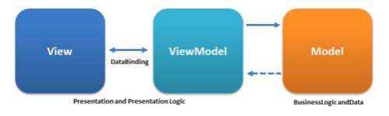
Figure 4: Model–view–viewmodel

5.3 Configuration and Customization
It's now time to install the programmer and begin configuring the functionalities
that may be used right away. In fact, this step should always come first before
developing any procedures or rushing to customize any module.

• The first step is to install and configure flutter. After that, we'll install it by
following the instructions on the official flutter website.
• The second step is to install and configure Android Studio, after which we
will install the flutter and dart plugins to use flutter in Android Studio.
• We built up an emulator in Android Studio to run and test our app in this
phase.
• The fourth step is to create a home screen. Then we used dart language
to create the home screen.
• We developed items and their product detail pages after designing the
home screen. Similarly, we have created each design component
separately.
• To pick numerous things at once, we have provided add to cart capability
to our app. The add to cart feature also allows you to buy numerous items
at once.
• We've introduced a login and registration form, and users must first
register and login before placing an order. This was accomplished using
firebase and flutter.
5.3.1 Flutter Firebase working
When a client (iOS or Android) requests a firebase API, the client sends its query
to the firebase database, which then responds to the firebase API and the client
(IOS or Android).
In Flutter, this is a lib folder where we can handle all our app's screens. This folder
also contains the functioning section. This folder is responsible for 90% of our
app development.
• Pubspec.yaml manages all our library files. This is a very private section
of our software. It is also space constrained.
• Two responsible libraries for firebase integration are
1.
firebase_core: ^1.16.0
2.
firebase_auth: ^3.3.17

• Flutter asset folder, where we keep track of all the assets for our flutter
app. Images, static data, videos, and other assets
• The IOS folder is responsible for all IOS development operations. Flutter
is a hybrid technology, which means it can manage several platforms.
• It manages all the tasks required for Android development, same as IOS.
5.3.2 Firebase Configuration for Android and IOS:
To use Firebase with Flutter, we must first create a Firebase console project.
We've established a project called Angel on Firebase. After that, we added
packages for Android and iOS.. We inserted a google json file for Android and an
info plish file for iOS in the root directory of both Android and iOS. This is how we
set up our Firebase application for iOS and Android. We've also included
packages in the pub spec files for authentication.
We received the project id, which is essentially our project's unique identification.
We also issued a project number, which we may use to configure integrations
with Firebase or other third-party services. We also gained the public facing
name, which will appear on emails sent to users after they create an account in
our application
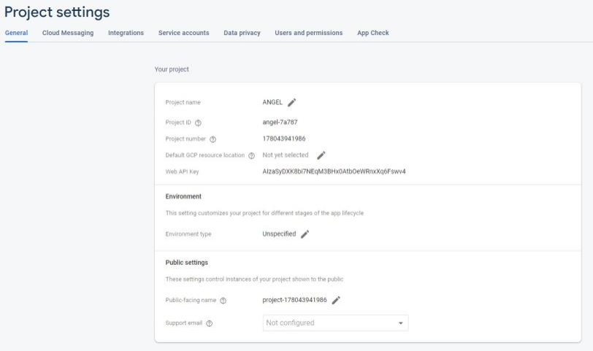
Figure 5: Firebase project settings
We ran into the following issues during configuration and customization.
• We placed the google services json file in a different location from the root
directory while configuring the application for Android. As a result, when
we test an application, we get unexpected problems. However, when we
place the google services json file in the root directory of Android, it does
not work.
• We had an authentication problem with the application while managing
sessions. When a user logs out of an application, they will be sent to the
home screen without having to log in again. This is a problem with
authentication. We have resolved in our app.
• We have a problem with password letters. When we enter a password with
fewer than six letters, it is not checked, and no error is displayed. We've
corrected the problem, and now the password must contain more than six
letters.
• When we add a product to a cart, it appears in the cart screen. This has
been a huge problem for us. This problem was handled by examining
indexes in an array. An array does not hold indexes. As a result, the cart
displays an empty value.
• Users do not need to log in before placing an order. We were able to
resolve this problem by utilizing session and authentication. Users must
now be logged in before placing an order or seeing the main home page.

6 CODE EXPLANATION
6.1 Assistance from the open sources and friend
I received design assistance from one of my mates as well as other sources. The
Shipping details page, intro screens, and Splash screen were created by a friend,
and the design was pulled from site on the internet and integrated into one.
We got a reasonably decent open-source code from GitHub for designing part of
the code and used parts of the code from that open source and made adjustments
to it by watching YouTube tutorials to add some other components as well.
(MonsieurZbanowanYY, no date)
We used the cart component with the help of YouTube instead of the search bar
on the top right side of the application. We've also created a shipping detail
section where we ask for buyer information such as address, phone number, and
so on. (The Flutter Way, 2020)
6.2 Whole Application background Function calling
When a user opens an app for the first time, we set a background function to call
once when the app is opened by a new user. It has 3 to 4 guides to keep users
entertained. When the home screen is opened, it calls the home screen widget,
which then calls the state widget to receive product data and display it in a grid
on the home screen.
Navigator is a tool that allows us to navigate data by category. When a user taps
on a product, we acquire its array index and retrieve the desired object detail.
When a user taps on a product (which are taken from an open source), the
product's details screen opens. On the detailed screen, we match a product's id
with the array and display data when the id matches the array index. (Unsplash)
On the detail screen, we have fields for description, price, add to cart, and buy
now. It will be added to the cart when the user clicks on add to cart. When a user
clicks the buy now button, they will be taken to the checkout page. If the user is
logged in, he or she can place an order; if not, the user must first log in to their
account, then register for an app, and then log in

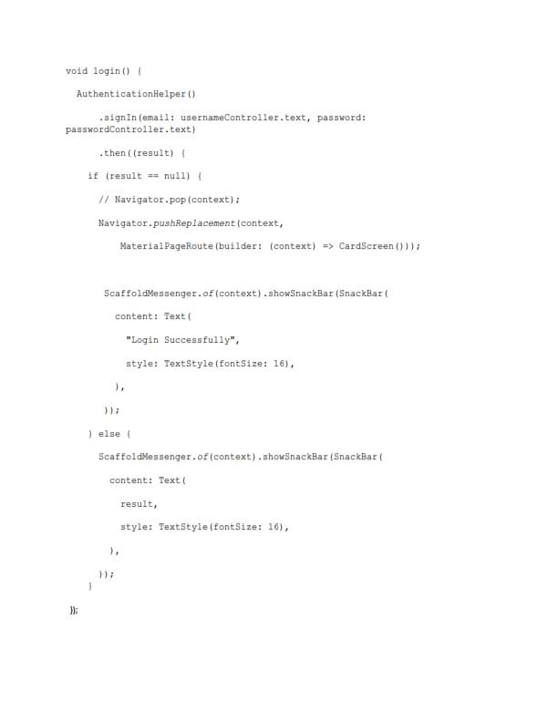
Figure 6: Login Code
When the user adds products to the cart, he or she will check the cart to see
which items have been added. He/she will inspect the items and proceed to
checkout from here. When he/she taps to check out again, the login session is
checked, and if he/she is not logged in, they must first log in before placing an
order.
We also display products underneath the details screen of each product, allowing
the user to select products from the same category. User interface processes are
managed by libraries. We just display a Thank You screen after the order is
placed. Because our program has numerous screens, we will discuss each
screen's workflow as well as the packages that are included in order to explain
the code.
6.3 Home Screen
As our Home screen has following categories Shirts, shoes, and purse. Every
product is associated with a specific category. We have made a dart file name as
Angel_Home_Screen.Dart. In this file our main home categories are managed.
Then we make a file name as prepare_data. In this file we make a class
Data_View_Model.
In this class we are managing our all products, categories as well as cart. We are
managing all the stuff in a single file in order to reduce no of files and optimization
of code. In this class we make a method for each functionality. In this class we
make get purse function in order to get all products in a purse. We make get shoe
ad get shirts as well in a same logic.
We added loops for every category where are the products in a category are
managed. If a category has 10 numbers of products, then loop move 10 time in
order to show all the products for a specific category.
As we use provider patterns for this application, so the main class extends
change notifier. By using this provider pattern listen about the list that are
prepared in this class. When any change occur in this class then it will notify to
provider about change. Basically, this is the best thing in providers for managing
data in application.
In our application we are using init function. Init function we are calling our
Data_View_Model class. Everything is prepared before running. Let’s suppose
you open an application. You can see only 1 category products by default. When
we click on other category notifier note the change and send to the listener that
is call in init() function. Then home screen data index is updated and across index
specific category products are call and display in a home screen.
6.4 Login Registration Screen
In login and registration page we are using stateful widget. In Stateful widget we
call its state. In Its state we are using scaffold widget. Scaffold is a layout of our
whole screen which gives us many things like App Bar, Body and many more.
We are using column widget to align in vertically direction. In column we have a
children. In Children we are using text fields. One for email and other for
password.
We have used signInWithEmailAndPassword and for the registration we have
used createUserWithEmailAndPassword API’s.
When a user enters email and password. A query is generated which checks
weather registered on firebase database or not. If credential are match it return a
true and we redirect it into the screen where they enter detail.
When a user login to their account, we save its email and give it to unique key.
When they press logout, its key will be removed and when they try to login again
we will give them a new key again. In this way we authenticate our user.
We are managing session as well when a login to their account session start and
when user logout an application it will be over. We are managing session by using
shared preferences in flutter. Shared preference allow us to manage user session
with a specific interval of time. We have added a package in pub spec in order to
use in flutter.
shared_preferences: ^2.0.13
These packages are used in application to perform login and registration.
Firebase core provide us an access to the flutter database. Firebase core also
allow us to perform initialization actions. On the other hand, Firebase auth allow
us to authenticate user when they perform registration or Login. By using these
packages, we can use firebase APIs for login or registration.
firebase_core: ^1.16.0
firebase_auth: ^3.3.17
6.5 Add to Card Screen
In Add to cart screen we are using stateful widget. In Stateful widget we call its
state. In Its state we are using scaffold widget. Scaffold is a layout of our whole
screen which gives us many things like App Bar, Body and many more. We are
using column widget to align in vertically direction. In column we have a children.
In Children we are using list view. In list view widget all the selected items are
arranged.
Session check also included in add to cart functionality. If a user login to their
account, then its session started then they will purchase product by using add to
cart functionality. It is very good practice to use session in purchasing points to
authenticate user.
We are fetching a data in our list view which index marked as true. In every item
in list view, we are making edit and delete button. Below list view we are using
elevation button to proceed to checkout. Elevation button has a on tap
functionality. We set checkout page path in on tap functionality

7 Discussion and Further Development
Online purchasing has grown increasingly popular in recent years. People all over
the world prefer to purchase online rather than go to the store, which is why
Amazon and other similar online stores are not only profitable but also generating
interest in online business. Many new strategies and technologies have been
created in e-commerce apps to offer users with information. Online commerce is
experiencing considerable development all around the world.
We've provided answers, but they'll need some time and resources. This App will
provide users with modules to help them with their task. The player's major goal
in building the app was to prioritize quality above quantity. As previously
indicated, more modules and functionality will be introduced soon to make the
program more solid and adaptable.
The primary goal and aim of this program are to enable and assist people in using
an e-commerce-based platform, which is widely utilized throughout the world for
online shopping and purchase of commodities and products nowadays. As a
result, individuals may enjoy, conveniently access, and purchase all things
through internet shopping and feel fully integrated into society. Our effort will not
end here; we will continue to improve the software and provide new features for
those who are unable to perceive the world from any angle (completely blind
people). We'll aim to include a feature that makes this app totally accessible to
blind people; they'll be able to control it with their voice and dress themselves
according to their preferences. We'll be adding additional features as time goes
on.

REFERENCES
Abilitynet. 2013. How to use TalkBack in Android Jelly Bean. Read on
25.05.2022.
https://mcmw.abilitynet.org.uk/talkback-android-jelly-bean-4-2-2

Android Accessibility Help. 2022. Get started on Android with TalkBack. Read on
11.05.2022.
https://support.google.com/accessibility/android/answer/6283677?hl=en

AppDividend. no date. Flutter Mobile Development Guide For Beginners. Read
on 08.05.2022.
https://appdividend.com/category/flutter/

Code Carbon. 2020. Major Advantages And Disadvantages Of Dart Language.
Read on 15.05.2022.
https://codecarbon.com/pros-cons-dart-language/

Collin, C. 2021. 5 Critical Steps for Your Software Implementation Plan. Read on
11.05.2022.
https://www.softwareadvice.com/resources/software-implementation-plan/
Dart. No date. Dart programming language | Dart. Read on 05.05.2022.
https://dart.dev/
Darrell, R. 2011. The Future of Shopping. Harvard Business Review. Read on
08.05.2022.
https://hbr.org/2011/12/the-future-of-shopping
Everyday. No date. Essential reads: Where marketing meets strategy - Everyday
Online Marketing. Read on 05.05.2022.
https://everydayonlinemarketing.com/
Firebase. No date. Firebase documentation: Learn the fundamentals. Read on
01.05.2022.
https://firebase.google.com/docs
Flutter. no date. Flutter: Build apps for any screen. Read on 10.05.2022.
https://flutter.dev/
GeeksforGeeks. No date. A computer science portal for geeks. Read on
06.05.2022.
https://www.geeksforgeeks.org
Google. 2022. Everything you need to build on Android. Read on 24.05.2022.
https://developer.android.com/studio/features
James, H. 2022. What is Java? Definition, Meaning & Features of Java Platforms.
Read on 12.05.2022.
https://www.guru99.com/java-platform.html
Lockwood, B. no date. 10 Technology Challenges. Read on 03.05.2022.
https://sgrlaw.com/ttl-articles/10-technology-challenges/
Michael Aldrich Archive. No date. Welcome to the Michael Aldrich Archive. Read
on 09.05.2022.
https://www.aldricharchive.co.uk/

MonsieurZbanowanYY. 2022. E-Commerce-App-UI-Flutter. Read on
27.05.2022.
https://github.com/MonsieurZbanowanYY/E-Commerce-App-UI-Flutter
Nazmun Nessa Moon , Shaheena Sultana, Fernaz Narin Nur & Mohd
Saifuzzaman. 2017. A Literature Review of the Trend of Electronic Commerce in
Bangladesh Perspective. Read on 23.05.2022.
https://globaljournals.org/GJMBR_Volume17/3-A-Literature-Review-of-the
Trend.pdf
Oberlo. 2022. FULFILL YOUR DROPSHIPPING DREAMS. Read on 21.05.2022.
https://www.oberlo.com/
Pravine, V. no date. A 5-STEP PLAN FOR SOFTWARE IMPLEMENTATION
SUCCESS. Read on 18.05.2022.
https://www.chetu.com/blogs/technical-perspectives/software-implementation
plan.php
Richard F. Schmidt. 2013. Chapter 19 - Software Implementation. Read on
25.05.2022.
https://www.sciencedirect.com/science/article/pii/B9780124077683000197
Salesforce, Inc. 2022. CRM Software; Cloud Computing Solutions - Salesforce
EMEA. Read on 05.05.2022.
https://www.salesforce.com/eu/
Santex. No Date. 7 Steps for Software Implementation Success. Read on
20.05.2022.
https://santexgroup.com/blog/7-steps-for-software-implementation-success/
Shopify. No Date. Shopify: Start and grow your e-commerce business. Read on
17.05.2022.
https://www.shopify.com
The Flutter way. 2020. Online Shop App - Flutter UI - Speed Code. Published on
03.07.2020. Referred on 23.05.2022.
https://www.youtube.com/watch?v=XBKzpTz65Io
Unsplash . no date. Beautiful Free Images & Pictures | Unsplash. Read on
27.05.2022.
https://unsplash.com/
Wikipedia contributors. 2022. Model–view–viewmodel. In Wikipedia, The Free
Encyclopedia. Read on 05.05.2022.
https://en.wikipedia.org/w/index.php?title=Model%E2%80%93view%E2%80%9
3viewmodel&oldid=1088169504

E-Commerce APP

  - Web App (React-js)

Index
CHAPTER | DETAILS | PAGE  NO
1 | CHAPTER 1: INTRODUCTION  1.1 Client/Organization Profile  1.2 Need for System  1.3 Scope & Feasibility of Work  1.4 Operating Environment – H/w & S/w  1.5 Architecture of system  1.6 Detail Description of Technology Used | 1-9
1 |  | 1
1 |  | 1
1 |  | 2
1 |  | 3
1 |  | 4-5
1 |  | 6-9
2 | PROPOSED SYSTEM  2.1 Proposed System  2.2 Objectives of System  2.3 User Requirements | 10-12
2 |  | 10
2 |  | 11
2 |  | 12
3 | ANALYSIS & DESIGN  3.1 DFD  3.2 Table specifications (Database)  3.3 ERD  3.4 Object Diagram  3.5 Class Diagram  3.6 Use Case Diagrams  3.7 Web Site Map Diagram (if Website ) | 13-27
3 |  | 13-14
3 |  | 15-22
3 |  | 23
3 |  | 24
3 |  | 25
3 |  | 26
3 |  | 27
4 | USER MANUAL  4.1 User Interface Design (Screens etc.)  4.2 Limitations  4.3 Future enhancement | 28-41
4 |  | 28-40
4 |  | 41
4 |  | 41
 | BIBLIOGRAPHY  ANNEXURE: SAMPLE PROGRAM CODE  Synopsis  Progress Report | 42-45
 |  | 42-45
 |  | 46
 |  | 49

CHAPTER 1:
Introduction :
1.1 Client/Organization profile:
• Organization/Client Name: Vardhaman Om Paper Product
• Location: Gate no-1010, opp nisarg hotel, mangdewadi , katraj pune-
411046, Maharastra, India
• Email: ompaperproduct@gmail.com
About Organization:
Om Paper Products is one of the leading manufacturers of Aluminium Foil
Containers, Printed Paper Cup, Plastic Disposable Trays etc. We direct all our
activities to cater the expectations of customers by providing them excellent
quality products as per their gratifications. Moreover, we follow moral
business policies and crystal pure transparency in all our transactions to keep
healthy relations with the customers.
For our accomplishment story, we are grateful to our owner, “Aditya
(Owner)”, whose continual backing and direction have been useful to us for
attaining exponential development in the current market.
1.2 Need for System:
Organization currently doing business without any publicity on online platform.
The client need to develop website for their organization for selling products.
The requirement about this website is mainly selling their product online.
- Seurity – User’s data will be secured with username and password
1.3Scope & Feasibility of Work:
The System “Ecommerce website” will be a website where manufacturers who are
willing to sell product/goods online and similarly customer who wants to purchase
products online. Website will be available for 24/7. User will be able to run any kind
of business using website. Customers can purchase product very easily.
Feasibility of Work :
Feasibility is the determination of whether or not a project is worth doing the process
followed by making this determination is called a feasibility study. This of determine
if a project can and should be taken. Once it has been determined that a project is
feasible, the analyst can go ahead and prepare the project specification which finalizes
project requirements. Generally, feasibility studies are undertaken within right time
constraints and normally culminate in a written and oral feasibility report.
1. Technical feasibility:
The technical issue usually raised during the feasibility stage of the investigation
includes the following:
• Does the necessary technology exist to do what is suggested
• Do the proposed equipment’s have the technical capacity to hold the data
required to use the new system?
• Will the proposed system provide adequate response to inquiries, regardless
of the number or location of users?
• Can the system be upgraded if developed?
• Are there technical guarantees of accuracy, reliability, ease of access
and data security?
2. Operational feasibility:
Proposed projects are beneficial only ifthey can be turned out into information systems,
which will meet the organization’s operating requirements. Operational feasibility
aspects of the project are to be taken as an important part of the project implementation.
Some of the important issues raised are to test the operational feasibility of a project
includes the following:
• Is there sufficient support for the management from the users?
• Will the system be used and work properly if it is being developed and
implemented?
• Will there be any resistance from the user that will undermine the possible
application benefits?
This system is targeted to be in accordance with the above mentioned issues.
Beforehand, the management issues and user requirements have been taken into
consideration. So there is no question of resistance from the users that can undermine
the possible application benefits. The well planned design would ensure the optimal
utilization of the computer resources and would help in the improvement of
performance status.
3. Economic feasibility:
A system that can be developed technically and that will be used if installed must still
be a good investment for the organization. In the economic feasibility, the development
cost in creating the system is evaluated against the ultimate benefit derived from the
new systems. Financial benefits must equal or exceed the costs. The system is
economically feasible. It does not require any additional hardware or software.
1.4 Operating Environment –
H/w & S/w Hardware
required:
• RAM : 2 GB
• CPU Speed : 2.0 GHZ
• Hard Disk : 250 GB
Software required:
➢ User side Software:
• Windows
• Linux
• Technology: JAVA, SPRINGBOOT
• IDE : Spring Tool Suite
• Client Side Technologies: HTML, CSS, JavaScript , Bootstrap
• Server Side Technologies: Java
• Data Base Server: Sql
Operating System: Microsoft Windows/Linux
1.5Architectute Of System
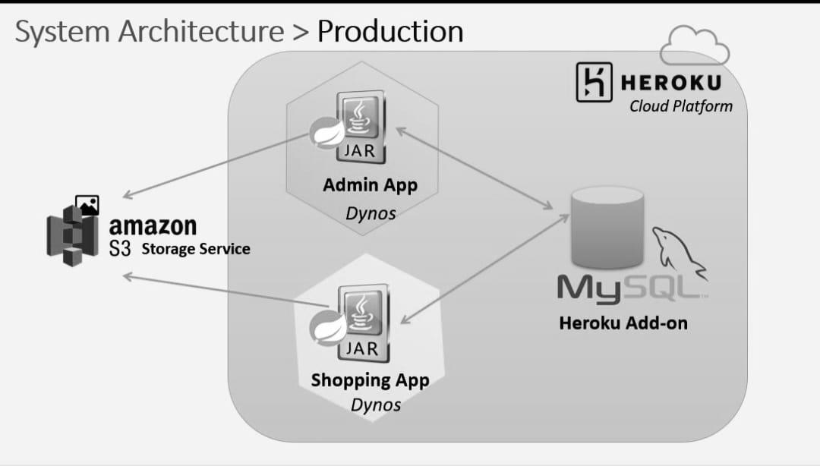

1.6 Detailed Description of Technology Used:
Html5
Introduction: HTML stands for Hyper Text Markup Language. It is used to design web
pages using a markup language. HTML is an abbreviation of Hypertext and Markup
language. Hypertext defines the link between the web pages. The markup language is
used to define the text document within the tag which defines the structure of web
pages. HTML 5 is the fifth and current version of HTML. It has improved the markup
available for documents and has introduced application programming interfaces(API)
and Document Object Model(DOM).
Features:
It has introduced new multimedia features which support audio and video controls by
using <audio> and <video> tags.
There are new graphics elements including vector graphics and tags.
Enrich semantic content by including <header> <footer>, <article>, <section> and
<figure> are added.
Drag and Drop- The user can grab an object and drag it further dropping it to a new
location.
Geo-location services- It helps to locate the geographical location of a client.
Web storage facility which provides web application methods to store data on the web
browser.
Bootstrap4
Bootstrap 4 is the newest version of Bootstrap. Bootstrap can be defined as a free and
open-source framework that can be used to create responsive, mobile-first, front-end
web pages

Advantages of Bootstrap:
There are various different advantages of Bootstrap, a few of them are given below:
The first and foremost advantage of using Bootstrap is that it is very easy to use and
implement. If a person has some basic knowledge of HTML and CSS, that user can
easily use Bootstrap.
The fact that Bootstrap can adapt to the size of any phone, tablet, desktop and so on is
also very interesting feature.
Bootstrap 4 is also useful because it is compatible with all modern browsers which
include Google Chrome, Firefox, Internet Explorer 10+, Edge, Safari, and Opera.
It also produces less cross-browser bugs.
It is light weighted and consequently it can be widely used as a framework for creating
responsive sites.
Lastly, Bootstrap 4 is a very simple and yet very effective grid system.
Why should one use Bootstrap?
There are multiple reasons for that, such as:
It is a way more fast and simpler way to develop websites.
It can create platform-independent web pages.
It can also create responsive web pages.
The web pages created by using Bootstrap 4 can be easily made responsive.
Javascript
What is JavaScript ?
JavaScript is a dynamic computer programming language. It is lightweight and most
commonly used as a part of web pages, whose implementations allow client-side script
to interact with the user and make dynamic pages. It is an interpreted programming
language with object-oriented capabilities.
JavaScript was first known as LiveScript, but Netscape changed its name to JavaScript,
possibly because of the excitement being generated by Java. JavaScript made its first
appearance in Netscape 2.0 in 1995 with the name LiveScript. The general-purpose
core of the language has been embedded in Netscape, Internet Explorer, and other web
browsers.
Advantages of JavaScript
The merits of using JavaScript are −
Less server interaction − You can validate user input before sending the page off to the
server. This saves server traffic, which means less load on your server.
Immediate feedback to the visitors − They don't have to wait for a page reload to see if
they have forgotten to enter something.
Increased interactivity − You can create interfaces that react when the user hovers over
them with a mouse or activates them via the keyboard.
Richer interfaces − You can use JavaScript to include such items as drag-and-drop
components and sliders to give a Rich Interface to your site visitors.
Jquery
jQuery is a fast, small, cross-platform and feature-rich JavaScript library. It is designed
to simplify the client-side scripting of HTML. It makes things like HTML document
traversal and manipulation, animation, event handling, and AJAX very simple with an
easy-to-use API that works on a lot of different type of browsers
The main purpose of jQuery is to provide an easy way to use JavaScript on your website
to make it more interactive and attractive. It is also used to add animation.
What is jQuery
jQuery is a small, light-weight and fast JavaScript library. It is cross-platform and
supports different types of browsers. It is also referred as ?write less do more? because
it takes a lot of common tasks that requires many lines of JavaScript code to accomplish,
and binds them into methods that can be called with a single line of code whenever
needed. It is also very useful to simplify a lot of the complicated things from JavaScript,
like AJAX calls and DOM manipulation.
jQuery is a small, fast and lightweight JavaScript library.
jQuery is platform-independent.
jQuery means "write less do more".
jQuery simplifies AJAX call and DOM manipulation.
Thymeleaf
The Thymeleaf is an open-source Java library that is licensed under the Apache License
2.0. It is a HTML5/XHTML/XML template engine. It is a server-side Java template
engine for both web (servlet-based) and non-web (offline) environments. It is perfect
for modern-day HTML5 JVM web development. It provides full integration with
Spring Framework.
It applies a set of transformations to template files in order to display data or text
produced by the application. It is appropriate for serving XHTML/HTML5 in web
applications.
The goal of Thymeleaf is to provide a stylish and well-formed way of creating
templates. It is based on XML tags and attributes. These XML tags define the execution
of predefined logic on the DOM (Document Object Model) instead of explicitly writing
that logic as code inside the template. It is a substitute for JSP.
The architecture of Thymeleaf allows the fast processing of templates that depends on
the caching of parsed files. It uses the least possible amount of I/O operations during
execution.
Why we use Thymeleaf?
JSP is more or less similar to HTML. But it is not completely compatible with HTML
like Thymeleaf. We can open and display a Thymeleaf template file normally in the
browser while the JSP file does not.
Thymeleaf supports variable expressions (${...}) like Spring EL and executes on model
attributes, asterisk expressions (*{...}) execute on the form backing bean, hash
expressions (#{...}) are for internationalization, and link expressions (@{...}) rewrite
URLs.
Like JSP, Thymeleaf works well for Rich HTML emails.
Spring framework
Spring is the most popular application development framework for enterprise Java.
Millions of developers around the world use Spring Framework to create high
performing, easily testable, and reusable code.
Spring framework is an open source Java platform. It was initially written by Rod
Johnson and was first released under the Apache 2.0 license in June 2003.
Spring is lightweight when it comes to size and transparency. The basic version of
Spring framework is around 2MB.
The core features of the Spring Framework can be used in developing any Java
application, but there are extensions for building web applications on top of the Java
EE platform. Spring framework targets to make J2EE development easier to use and
promotes good programming practices by enabling a POJO-based programming model.
Benefits of Using the Spring Framework
Following is the list of few of the great benefits of using Spring Framework −
Spring enables developers to develop enterprise-class applications using POJOs. The
benefit of using only POJOs is that you do not need an EJB container product such as
an application server but you have the option of using only a robust servlet container
such as Tomcat or some commercial product.
Spring is organized in a modular fashion. Even though the number of packages and
classes are substantial, you have to worry only about the ones you need and ignore the
rest.
Spring does not reinvent the wheel, instead it truly makes use of some of the existing
technologies like several ORM frameworks, logging frameworks, JEE, Quartz and JDK
timers, and other view technologies.
Testing an application written with Spring is simple because environment-dependent
code is moved into this framework. Furthermore, by using JavaBeanstyle POJOs, it
becomes easier to use dependency injection for injecting test data.
Spring's web framework is a well-designed web MVC framework, which provides a
great alternative to web frameworks such as Struts or other over-engineered or less
popular web frameworks.
Spring provides a convenient API to translate technology-specific exceptions (thrown
by JDBC, Hibernate, or JDO, for example) into consistent, unchecked exceptions.
Lightweight IoC containers tend to be lightweight, especially when compared to EJB
containers, for example. This is beneficial for developing and deploying applications
on computers with limited memory and CPU resources
Spring provides a consistent transaction management interface that can scale down to
a local transaction (using a single database, for example) and scale up to global
transactions (using JTA, for example).
Spring boot
Spring Boot is an open source Java-based framework used to create a micro Service. It
is developed by Pivotal Team and is used to build stand-alone and production ready
spring applications. This chapter will give you an introduction to Spring Boot and
familiarizes you with its basic concepts.
What is Micro Service?
Micro Service is an architecture that allows the developers to develop and deploy
services independently. Each service running has its own process and this achieves the
lightweight model to support business applications.
Advantages
Micro services offers the following advantages to its developers −
Easy deployment
Simple scalability
Compatible with Containers
Minimum configuration
Lesser production time
What is Spring Boot?

Spring Boot provides a good platform for Java developers to develop a stand-alone and
production-grade spring application that you can just run. You can get started with
minimum configurations without the need for an entire Spring configuration setup.
Advantages
Spring Boot offers the following advantages to its developers −
Easy to understand and develop spring applications
Increases productivity
Reduces the development time
Goals
Spring Boot is designed with the following goals −
To avoid complex XML configuration in Spring
To develop a production ready Spring applications in an easier way
To reduce the development time and run the application independently
Offer an easier way of getting started with the application
Spring security
Spring Security is a framework which provides various security features like:
authentication, authorization to create secure Java Enterprise Applications.
It is a sub-project of Spring framework which was started in 2003 by Ben Alex. Later
on, in 2004, It was released under the Apache License as Spring Security 2.0.0.
It overcomes all the problems that come during creating non spring security
applications and manage new server environment for the application.
This framework targets two major areas of application are authentication and
authorization. Authentication is the process of knowing and identifying the user that
wants to access.
Authorization is the process to allow authority to perform actions in the application.
We can apply authorization to authorize web request, methods and access to individual
domain.
Advantages
Spring Security has numerous advantages. Some of that are given below.
Comprehensive support for authentication and authorization.
Protection against common tasks
Servlet API integration
Integration with Spring MVC
Portability
CSRF protection
Java Configuration support
Spring data jpa with hibernate
Hibernate is a Java framework that simplifies the development of Java application to
interact with the database. It is an open source, lightweight, ORM (Object Relational
Mapping) tool. Hibernate implements the specifications of JPA (Java Persistence API)
for data persistence.
ORM Tool
An ORM tool simplifies the data creation, data manipulation and data access. It is a
programming technique that maps the object to the data stored in the database.
What is JPA?
Java Persistence API (JPA) is a Java specification that provides certain functionality
and standard to ORM tools. The javax.persistence package contains the JPA classes
and interfaces.
Advantages of Hibernate Framework
Following are the advantages of hibernate framework:
1) Open Source and Lightweight
Hibernate framework is open source under the LGPL license and lightweight.
2) Fast Performance
The performance of hibernate framework is fast because cache is internally used in
hibernate framework. There are two types of cache in hibernate framework first level
cache and second level cache. First level cache is enabled by default.
3) Database Independent Query
HQL (Hibernate Query Language) is the object-oriented version of SQL. It generates
the database independent queries. So you don't need to write database specific queries.
Before Hibernate, if database is changed for the project, we need to change the SQL
query as well that leads to the maintenance problem.
4) Automatic Table Creation
Hibernate framework provides the facility to create the tables of the database
automatically. So there is no need to create tables in the database manually.
5) Simplifies Complex Join
Fetching data from multiple tables is easy in hibernate framework.
6) Provides Query Statistics and Database Status
Hibernate supports Query cache and provide statistics about query and database status.

Chapter 2
Proposed System
2.1 Proposed System:
• The proposed system help in building application to buy, sell product or good online
using internet connection.
• Ecommerce is fast gaining ground as an accepted and used business paradigm.
• It provides searching facility by the product name so customers can easily search the
products accordingly.
• In proposed system every product description is given along the product.
• System will be error free, secure, reliable and fast management system.
• In this system we make user friendly environment to the user and provides the
continuous availability of the products.
• Website provide cash on delivery service.
2.2 Objectives of System:
• To provide every product for the customer in the minimum reasonable cost, customer
can purchase product every time.
• To manage details of products, category, brand, customer, shipping rates
• The purpose of System is to automate the existing manual system by the help of
computerized and full-fledged computer website, fulfilling their requirements, so that
their valuable data/information can be stored for a longer period.
• To storing the high amount of data in minimum time is less time consuming for the
organization.
• It is designed such a way that one can view all the updates of the products from any
place through online.

2.3 User Requirements:
➢ Requirement for Admin:
• Registration
• Login
• Add/Manage User
• Add/Manage Product
• Add/Manage category
• Manage Customers
• Add/Manage Shipping Rates
• View Orders
➢ Requirement for Customer:
• Registration
• Login
• View Product
• Search facility
• Review Product
• Order Product
• Change password

CHAPTER 3:
ANALYSIS & DESIGN
3.1.1 DFD Diagram:
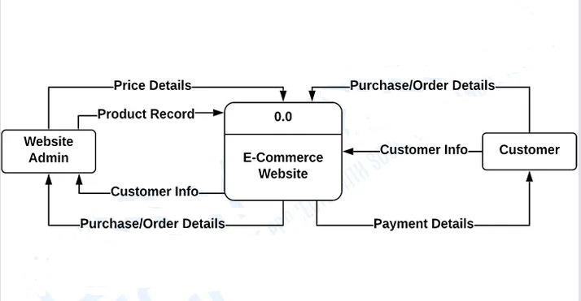
3.1.2 FIRST LEVEL DFD
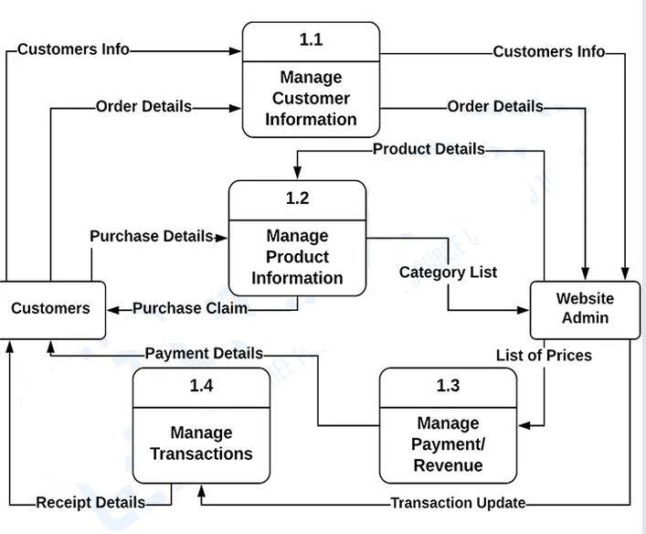
3.2 Table specifications (Database) :
Data Dictionary:
Table Name: Address
Table Name | Address
Table Description | It stores Address details.
Primary_key | Address_id
Foreign Key | custoId, countryId
Field Name | Data type | Description
First_name | Varchar(45) | Store first name
Last_name | Varchar(45) | Store last name
Phone_number | Varchar(45) | Store phone number
Address_line_1 | Varchar(45) | Store address line
Address_line_2 | Varchar(45) | Store address line
city | Varchar(45) | Store city code
state | Varchar(45) | Store state details
Postal code | Varchar(45) | Store postal code

Table Name: Customers
Table Name | Customers
Table Description | It stores customers details.
Primary_key | Cust_id
Foreign Key | Country_id
Field Name | Data type | Description
Email | Varchar(45) | Store email id of customer
Password | Varchar(45) | Store password of customer
First_name | Varchar(45) | Store first name of customer
Last_name | Varchar(45) | Store last name of customer
Phone_number | Varchar(45) | Store phone number of  customer
Address_line_1 | Varchar(45) | Store address of customer
Address_line_2 | Varchar(45) | Store address of customer
City | Varchar(45) | Store city of customer
State | Varchar(45) | Store state of customer
Postal code | Varchar(45) | Store postal code of customer

Table Name: Orders
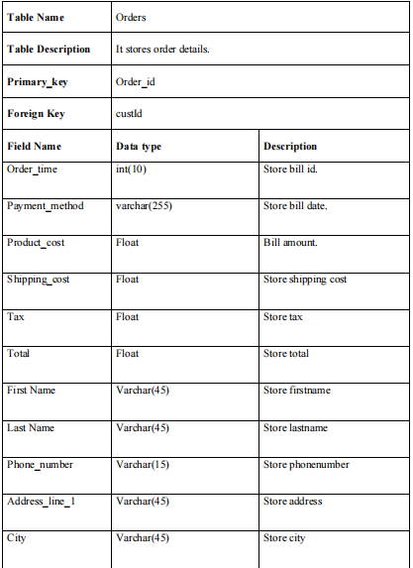

Table Name: Shipping Rates
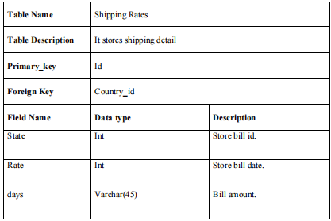
Table Name: Review
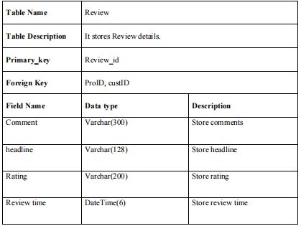
Table Name: Order Details
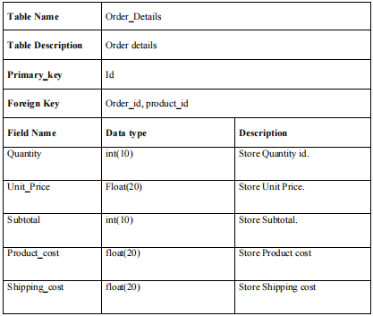
Brands:-
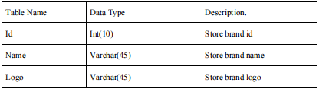

Table Name: Product
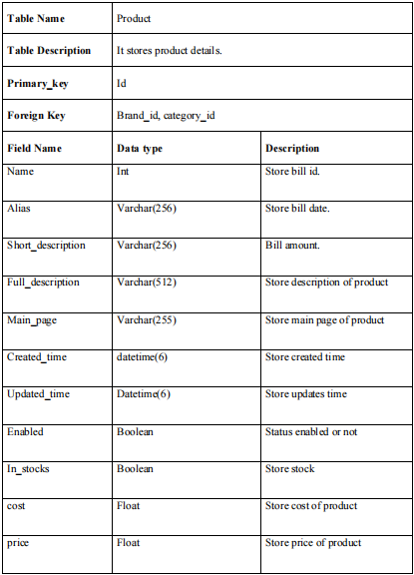
Table Name: Category
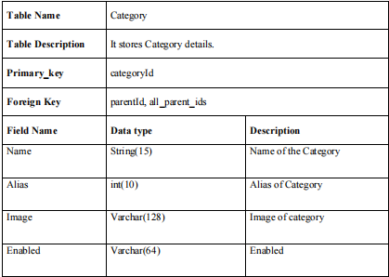
Table Name: Order_Track
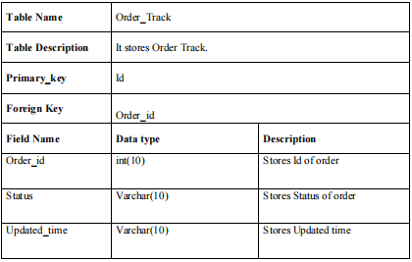
Table Name: Users
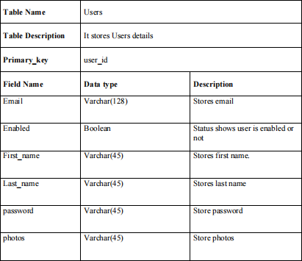

3.3 ERD Diagram:
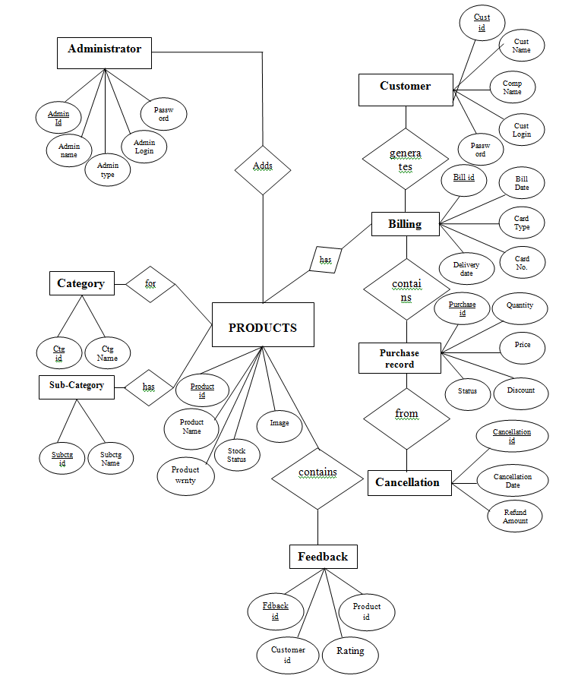

3.5 Class Diagram:
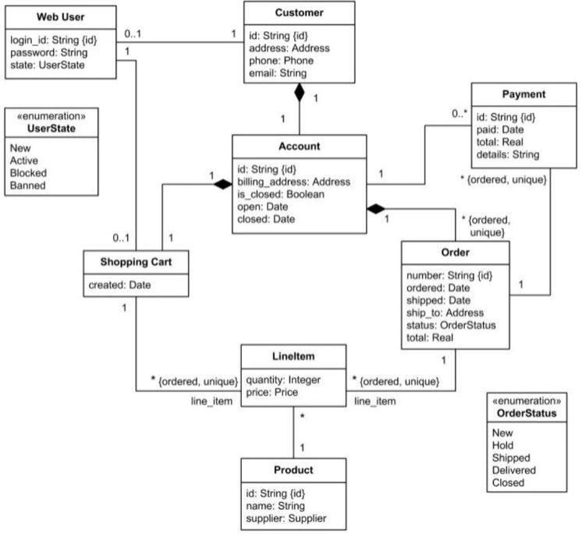

3.6 Use Case Diagrams:
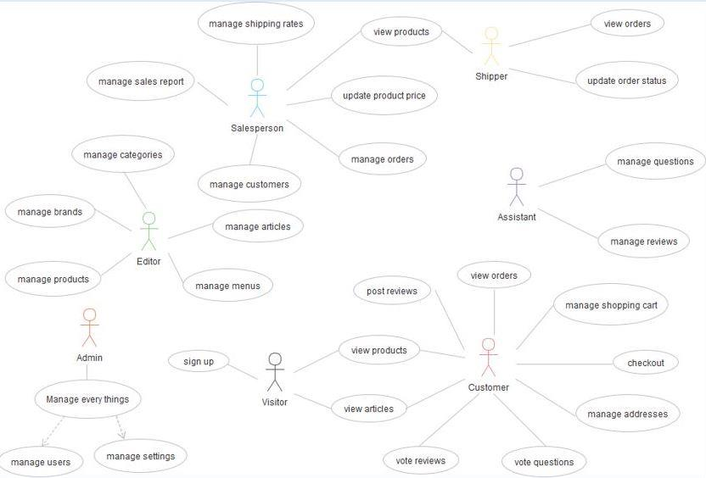

3.7 sequence diagram:
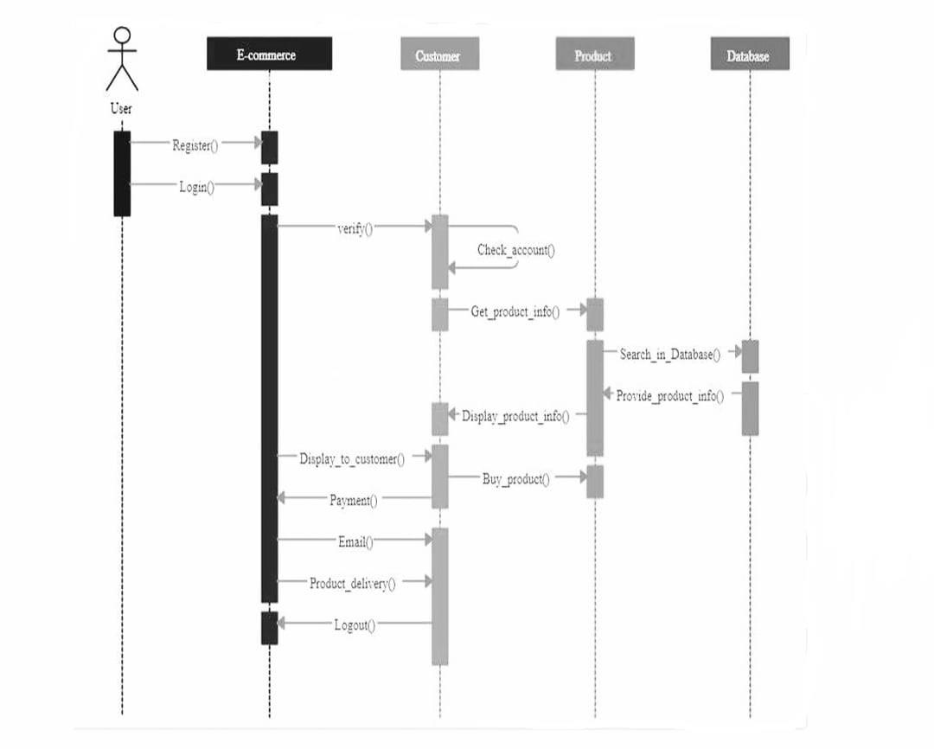

3.8 Website map diagram:
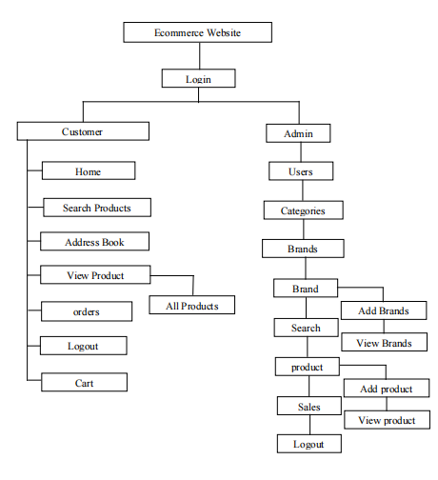

CHAPTER 4:
USER MANUAL
4.1 User Interface Design(Screens etc)
Fig 1 : Admin Login Page:
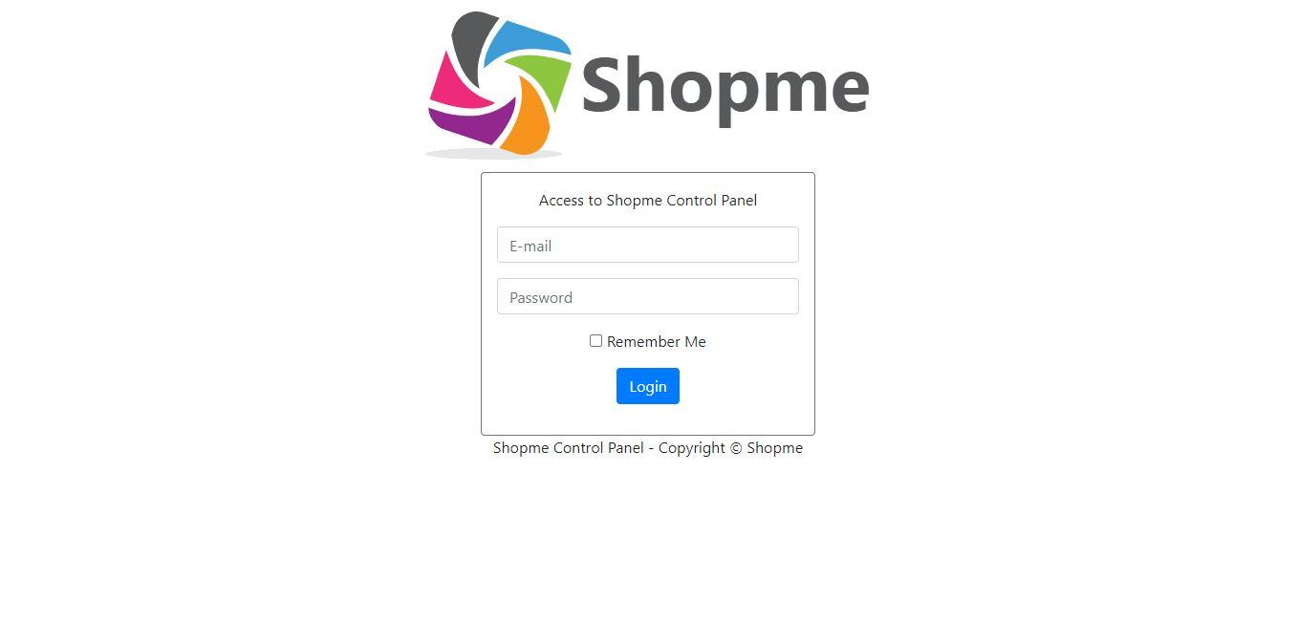
Fig 2: Create New Category:
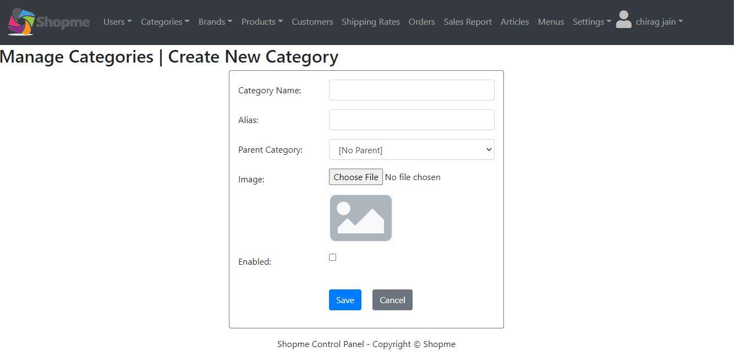

Fig 3: create new Brand
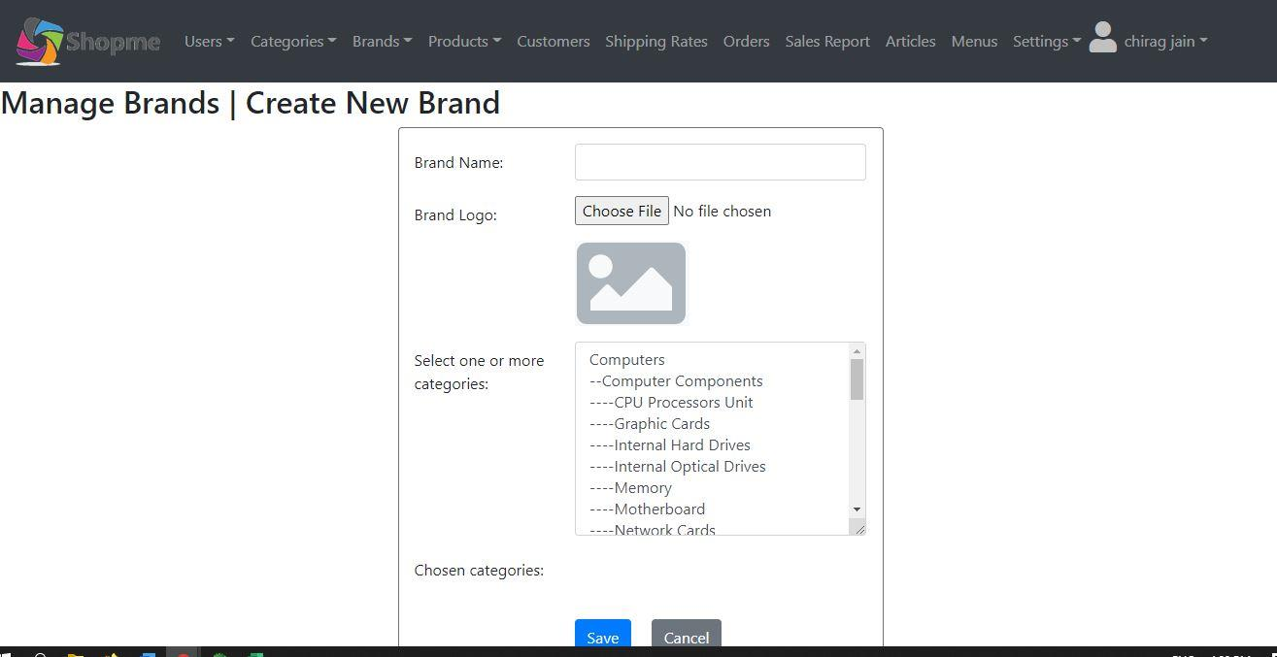

Fig 4: Manage Brands
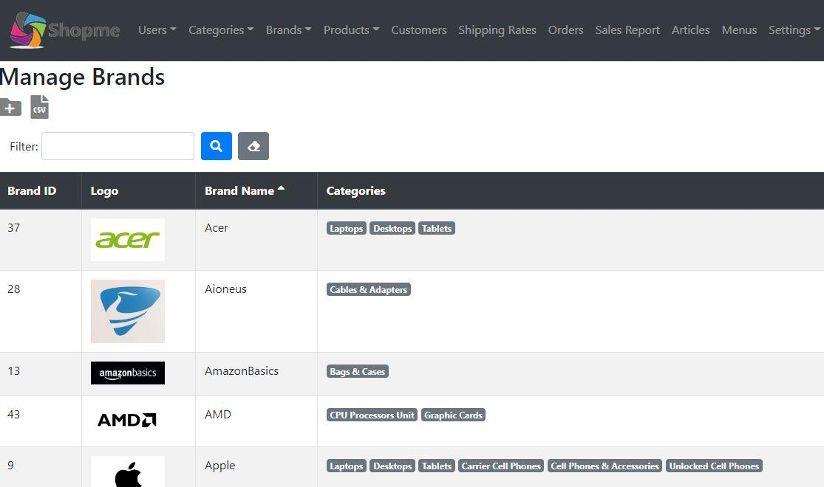
Fig 5: Manage Categories:
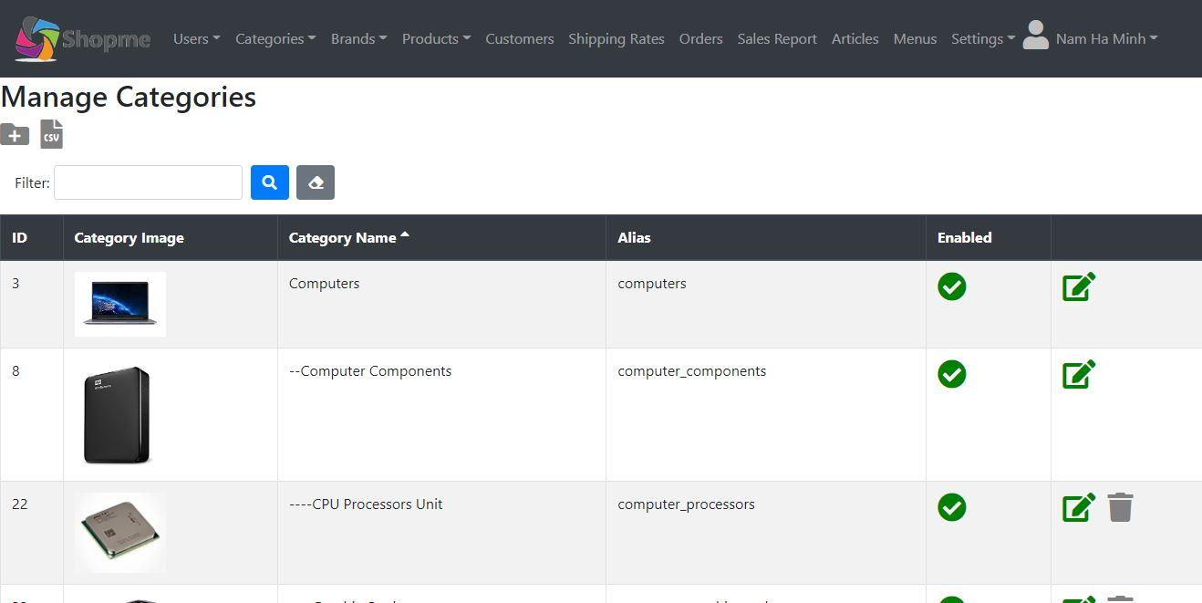bb
Fig 6: Manage Customers
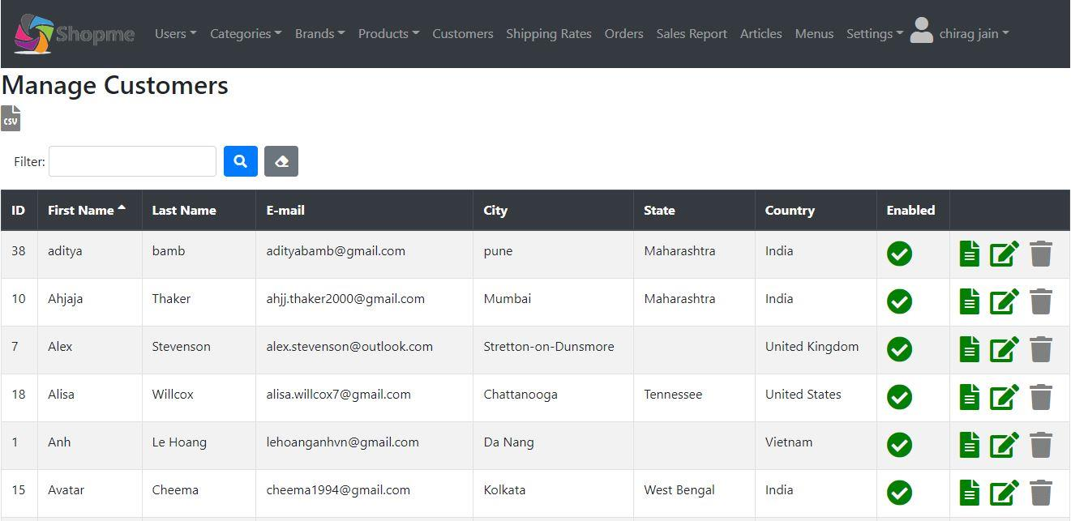

Fig 7: Manage Reviews
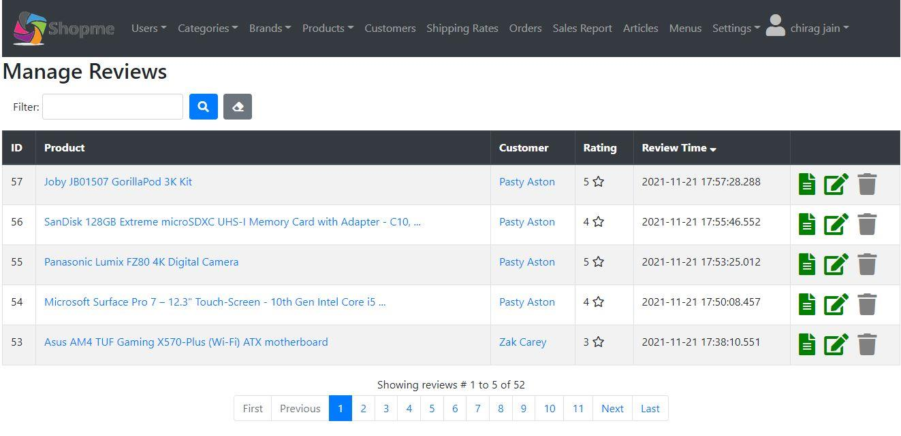

Fig 8: Manage Shipping Rates
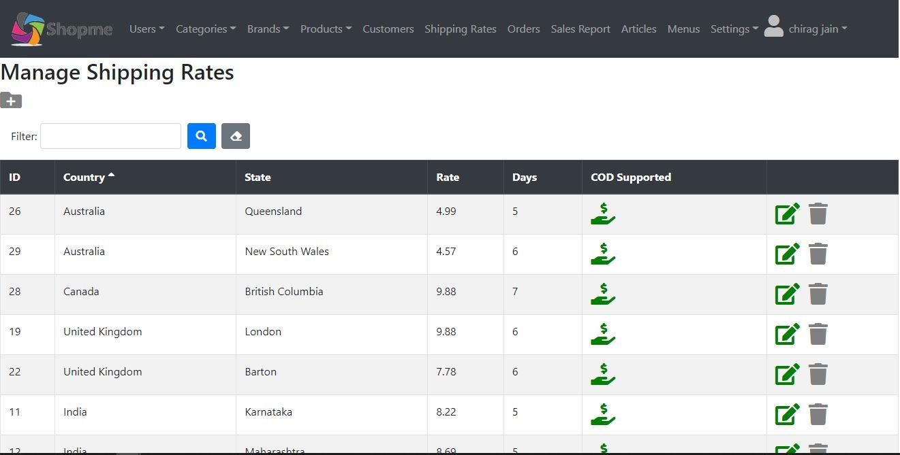

Fig 9: My Orders
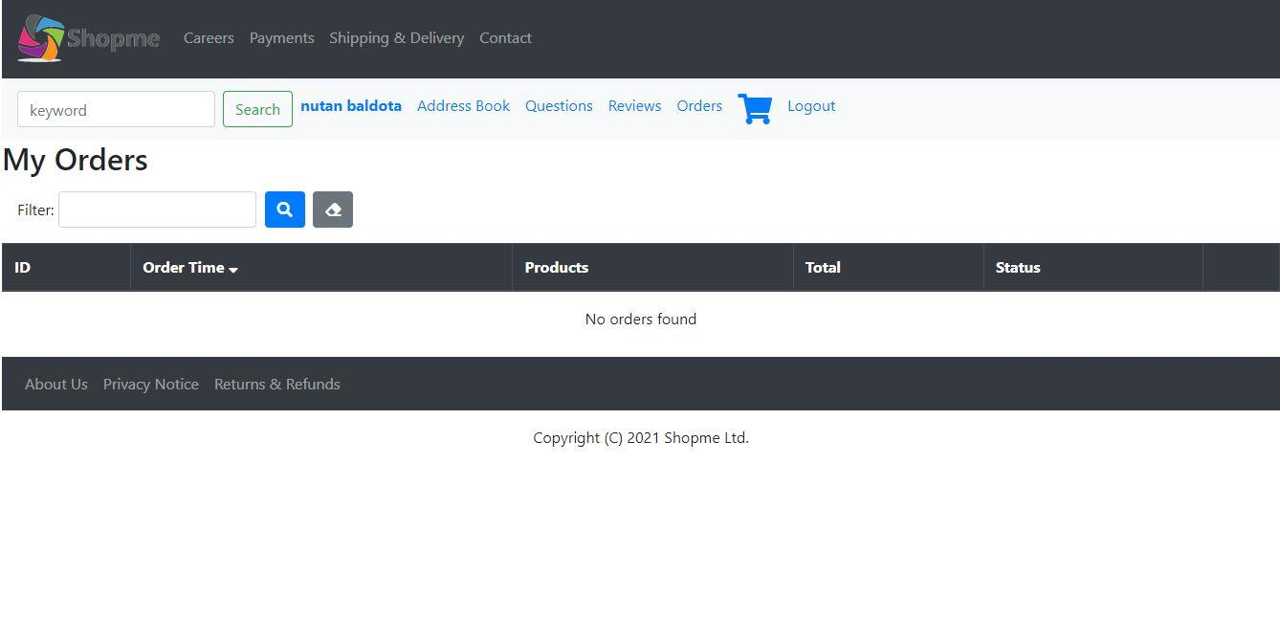
Fig 10: Sales Report
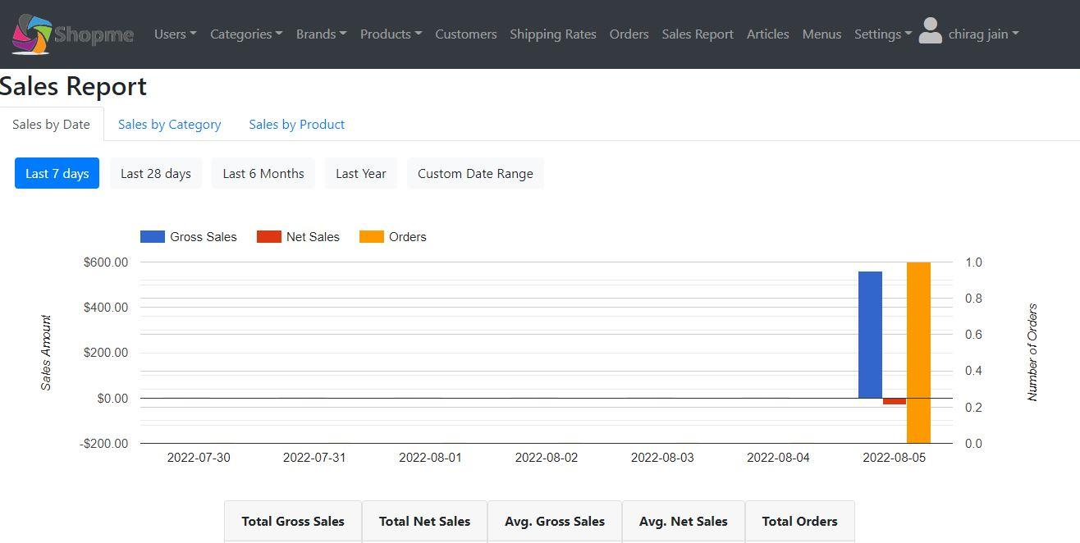

Fig 11: Site Setting
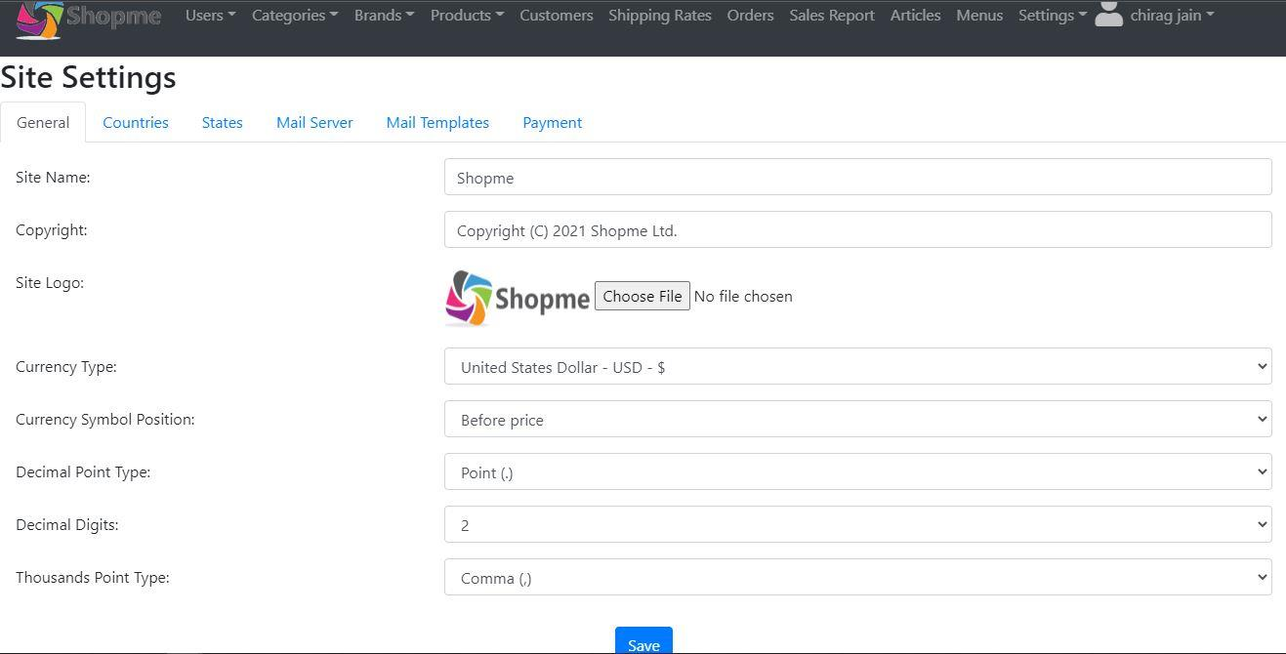

Test Cases
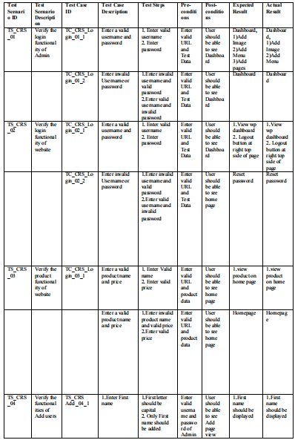
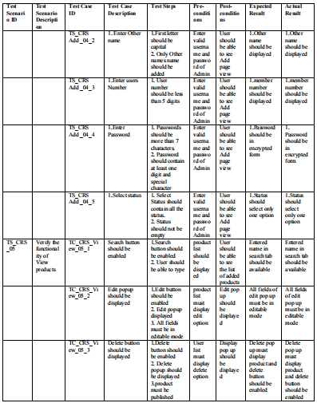

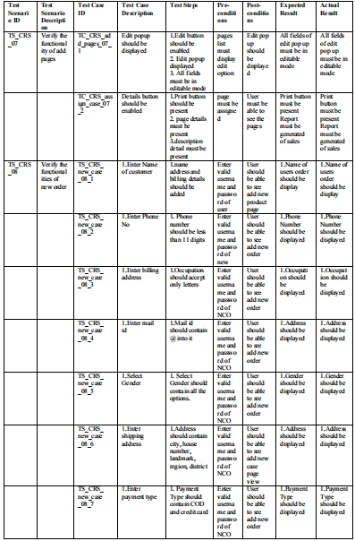
4.2 Limitations
1. Some business process may never be available to ecommerce:- Some items such as
foods, high cost items such as jwellery may be impossible to be available on the internet.
2. Legal issues:- these issues arises when the customer data is fall in the hands of
strangers.
3. Negotiation is not possible on online platform.
4,3 Future Enhancement
• Product recommendation using machine learning algorithm .
• Smart chat bot to improve customer service.
4,4 Bibliography
Website
• www.google.com
• https://spring.io/learn
• www.javapoint.com
Books
1. Spring microservices in Action
Author - john cornel
Publisher – Manning, July 6 2017
2 Learning Spring boot
Author – greg turnquest
Publisher – packt, November 3, 2017

ANNEXURE: SAMPLE PROGRAM CODE
BrandController.java –
package com.shopme.admin.brand;
import java.io.IOException;
import java.util.List;
import org.springframework.beans.factory.annotation.Autowired;
import org.springframework.stereotype.Controller;
import org.springframework.ui.Model;
import org.springframework.util.StringUtils;
import org.springframework.web.bind.annotation.GetMapping;
import org.springframework.web.bind.annotation.PathVariable;
import org.springframework.web.bind.annotation.PostMapping;
import org.springframework.web.bind.annotation.RequestParam;
import org.springframework.web.multipart.MultipartFile;
import org.springframework.web.servlet.mvc.support.RedirectAttributes;
import com.shopme.admin.AmazonS3Util;
import com.shopme.admin.category.CategoryService;
import com.shopme.admin.paging.PagingAndSortingHelper;
import com.shopme.admin.paging.PagingAndSortingParam;
import com.shopme.common.entity.Brand;
import com.shopme.common.entity.Category;
@Controller
public class BrandController {
private String defaultRedirectURL =
"redirect:/brands/page/1?sortField=name&sortDir=asc";
@Autowired private BrandService brandService;
@Autowired private CategoryService categoryService;
@GetMapping("/brands")
public String listFirstPage() {
return defaultRedirectURL;
}
@GetMapping("/brands/page/{pageNum}")
public String listByPage(
@PagingAndSortingParam(listName = "listBrands", moduleURL =
"/brands") PagingAndSortingHelper helper,
@PathVariable(name = "pageNum") int pageNum
) {
brandService.listByPage(pageNum, helper);
return "brands/brands";
}
@GetMapping("/brands/new")
public String newBrand(Model model) {
List<Category> listCategories =
categoryService.listCategoriesUsedInForm();
model.addAttribute("listCategories", listCategories);
model.addAttribute("brand", new Brand());
model.addAttribute("pageTitle", "Create New Brand")
return "brands/brand_form";
}
@PostMapping("/brands/save")
public String saveBrand(Brand brand, @RequestParam("fileImage") MultipartFile
multipartFile,
RedirectAttributes ra) throws IOException {
if (!multipartFile.isEmpty()) {
String fileName =
StringUtils.cleanPath(multipartFile.getOriginalFilename());
brand.setLogo(fileName);
Brand savedBrand = brandService.save(brand);
String uploadDir = "brand-logos/" + savedBrand.getId();
AmazonS3Util.removeFolder(uploadDir);
AmazonS3Util.uploadFile(uploadDir, fileName,
multipartFile.getInputStream());
} else {
brandService.save(brand);
}
ra.addFlashAttribute("message", "The brand has been saved successfully.");
return defaultRedirectURL;
}
@GetMapping("/brands/edit/{id}")
public String editBrand(@PathVariable(name = "id") Integer id, Model model,
RedirectAttributes ra) {
try {
Brand brand = brandService.get(id);
List<Category> listCategories =
categoryService.listCategoriesUsedInForm();
model.addAttribute("brand", brand);
model.addAttribute("listCategories", listCategories);
model.addAttribute("pageTitle", "Edit Brand (ID: " + id + ")");
return "brands/brand_form";
} catch (BrandNotFoundException ex) {
ra.addFlashAttribute("message", ex.getMessage());
return defaultRedirectURL;
}
}
@GetMapping("/brands/delete/{id}")
public String deleteBrand(@PathVariable(name = "id") Integer id,
Model model,
RedirectAttributes redirectAttributes) {
try {
brandService.delete(id);
String brandDir = "brand-logos/" + id;
AmazonS3Util.removeFolder(brandDir);
redirectAttributes.addFlashAttribute("message",
"The brand ID " + id + " has been deleted
successfully");
} catch (BrandNotFoundException ex) {
redirectAttributes.addFlashAttribute("message", ex.getMessage());
}
return defaultRedirectURL;
}
}
Customer.controller
package com.shopme.admin.customer;
import java.util.List;
import org.springframework.beans.factory.annotation.Autowired;
import org.springframework.stereotype.Controller;
import org.springframework.ui.Model;
import org.springframework.web.bind.annotation.GetMapping;
import org.springframework.web.bind.annotation.PathVariable;
import org.springframework.web.bind.annotation.PostMapping;
import org.springframework.web.servlet.mvc.support.RedirectAttributes;
import com.shopme.admin.paging.PagingAndSortingHelper;
import com.shopme.admin.paging.PagingAndSortingParam;
import com.shopme.common.entity.Country;
import com.shopme.common.entity.Customer;
import com.shopme.common.exception.CustomerNotFoundException;
@Controller
public class CustomerController {
private String defaultRedirectURL =
"redirect:/customers/page/1?sortField=firstName&sortDir=asc";
@Autowired private CustomerService service;
@GetMapping("/customers")
public String listFirstPage(Model model) {
return defaultRedirectURL;
}
@GetMapping("/customers/page/{pageNum}")
public String listByPage(
@PagingAndSortingParam(listName = "listCustomers",
moduleURL = "/customers") PagingAndSortingHelper helper,
@PathVariable(name = "pageNum") int pageNum) {
service.listByPage(pageNum, helper);
return "customers/customers";
}
@GetMapping("/customers/{id}/enabled/{status}")
public String updateCustomerEnabledStatus(@PathVariable("id") Integer id,
@PathVariable("status") boolean enabled, RedirectAttributes
redirectAttributes) {
service.updateCustomerEnabledStatus(id, enabled);
String status = enabled ? "enabled" : "disabled";
String message = "The Customer ID " + id + " has been " + status;
redirectAttributes.addFlashAttribute("message", message);
return defaultRedirectURL;
}
@GetMapping("/customers/detail/{id}")
public String viewCustomer(@PathVariable("id") Integer id, Model model,
RedirectAttributes ra) {
try {
Customer customer = service.get(id);
model.addAttribute("customer", customer);
return "customers/customer_detail_modal";
} catch (CustomerNotFoundException ex) {
ra.addFlashAttribute("message", ex.getMessage());
return defaultRedirectURL;
}
}
@GetMapping("/customers/edit/{id}")
public String editCustomer(@PathVariable("id") Integer id, Model model,
RedirectAttributes ra) {
try {
Customer customer = service.get(id);
List<Country> countries = service.listAllCountries();
model.addAttribute("listCountries", countries);
model.addAttribute("customer", customer);
model.addAttribute("pageTitle", String.format("Edit Customer (ID:
%d)", id));
return "customers/customer_form";
} catch (CustomerNotFoundException ex) {
ra.addFlashAttribute("message", ex.getMessage());
return defaultRedirectURL;
}
}
@PostMapping("/customers/save")
public String saveCustomer(Customer customer, RedirectAttributes ra) {
service.save(customer);
ra.addFlashAttribute("message", "The customer ID " + customer.getId() + "
has been updated successfully.");
return defaultRedirectURL;
}
@GetMapping("/customers/delete/{id}")
public String deleteCustomer(@PathVariable Integer id, RedirectAttributes ra) {
try {
service.delete(id);
ra.addFlashAttribute("message", "The customer ID " + id + " has
been deleted successfully.");
} catch (CustomerNotFoundException ex) {
ra.addFlashAttribute("message", ex.getMessage());
}
return defaultRedirectURL;
}
}

